Stolen violin

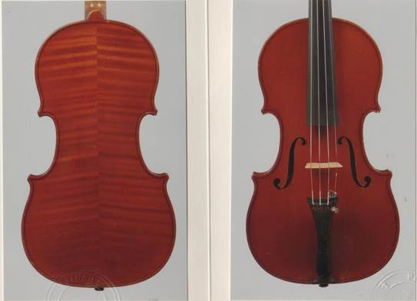

|  |  |  |
| --- | --- | --- |
|  | |  |
| cid:image002.jpg@01D01B88.E6D49CA0 | cid:image003.jpg@01D01B88.E6D49CA0 | CONTACT:  Pierre-Olivier Galbrun 123, avenue du Roi 1190 Forest Belgique-Bruxelles Gsm : +32 484 719 519 Tél : [+32 2 512 41 38](tel:%2B32%202%20512%2041%2038) |